Author Guideline

# Guidelines for Authors and Presenters at INCIRESMA 2025

We are pleased to announce that INCIRESMA 2025 will utilize the OJS 3 system for article processing, adhering to international standards to ensure a professional and efficient submission process. Through this system, authors can conveniently track the status of their submissions. Please refer to the following information for a step-by-step guide.

# OJS 3 INCIRESMA 2025 Registration

* + All presenters must create an account in the OJS 3 INCIRESMA system before submitting their manuscripts.
  + 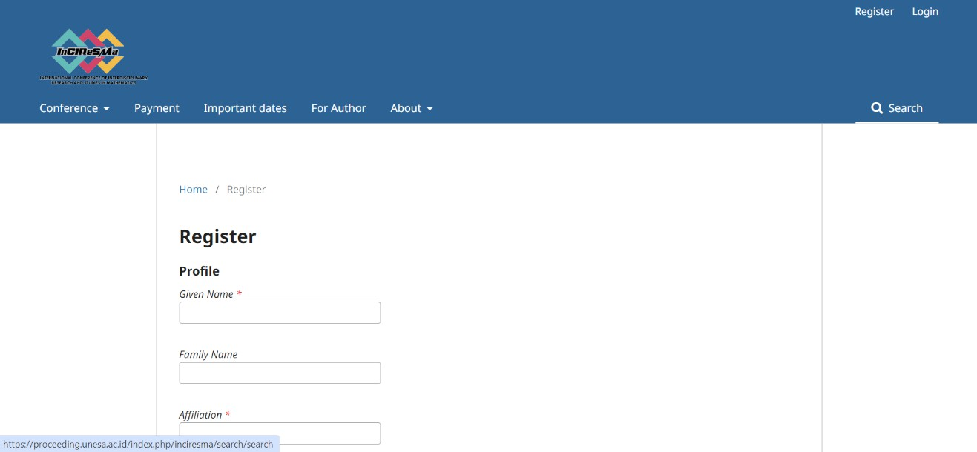Visit the registration page. <https://proceeding.unesa.ac.id/index.php/inciresma/user/register>
  + Ensure that you complete the registration form accurately.
  + After registration, participants will receive a username and password. Please keep your credentials secure, as they will be required for updating personal information, submitting the full paper, and tracking manuscript progress.

# Abstract Submission

* + To submit an abstract, log in to your account and visit the submissionpage: <https://proceeding.unesa.ac.id/index.php/inciresma/submission>
  + 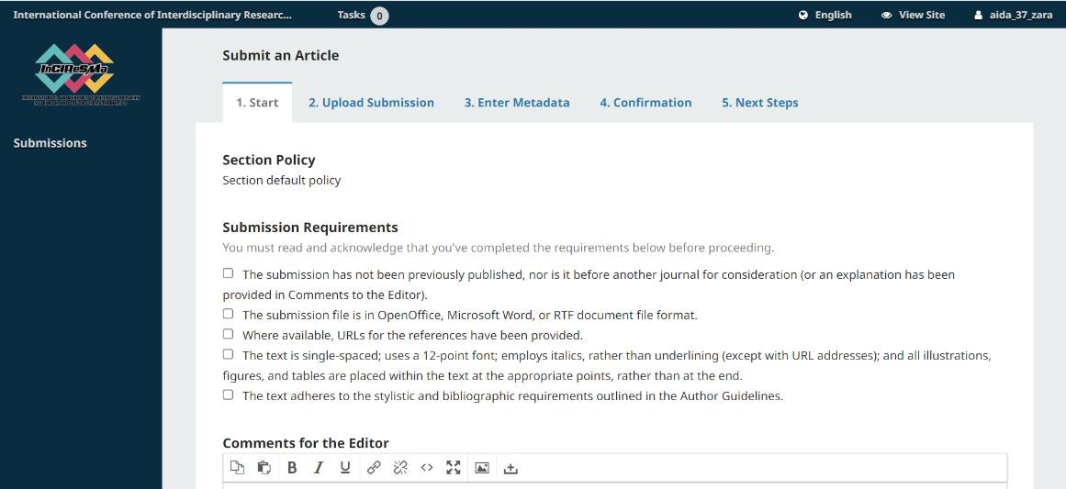Select the appropriate scope that best aligns with your research topic.

* + Complete the submission form and ensure that all required fields are filled out.
  + Prepare your abstract document in **.doc** or **.docx** format before uploading.
  + If your submission is successful, the submission menu will confirm the process.

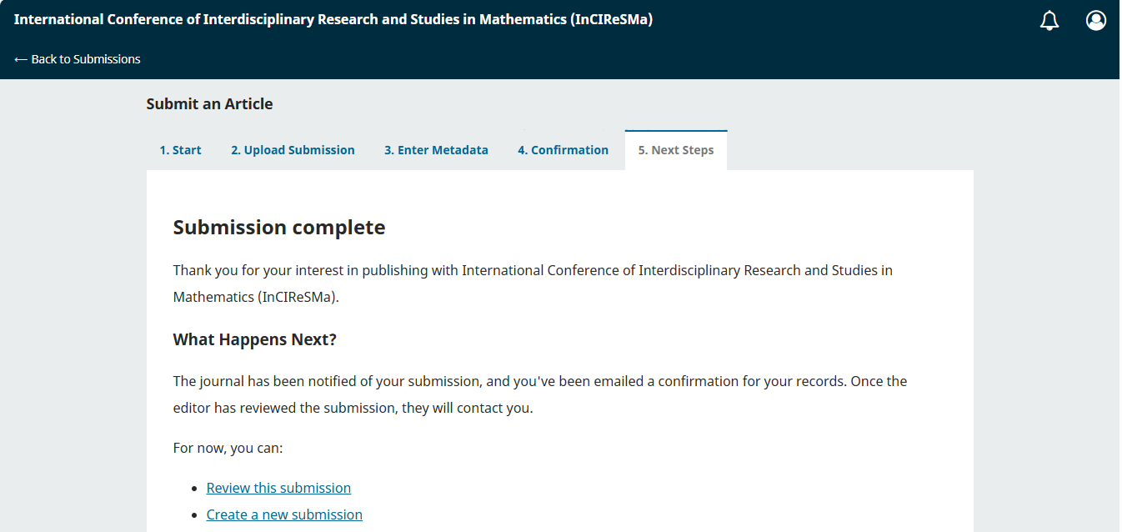

* + If you select “Review this submission”, the submission menu will be displayed as follows  
    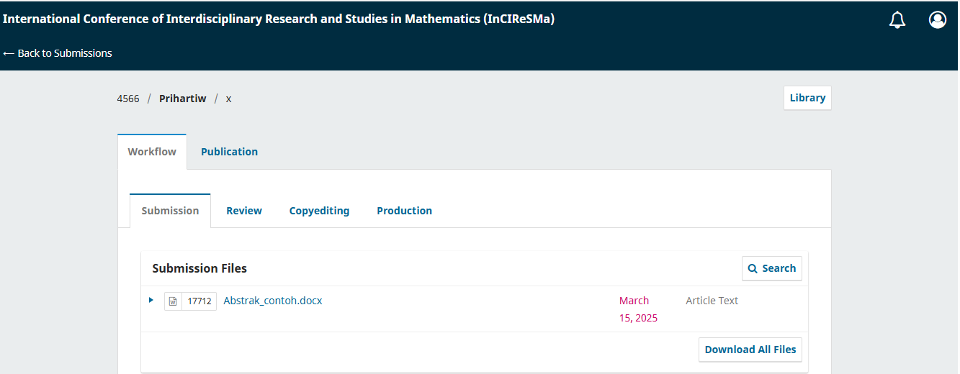

# Full paper Submission

* + Submit your full paper via the submission page:

<https://proceeding.unesa.ac.id/index.php/inciresma/submission>

* + Follow the article template for formatting guidelines (the template can be downloaded from the website).
  + Upload your manuscript in **.doc** or **.docx** format.
  + Manuscripts must adhere to formatting requirements and academic writing standards (e.g., within the required word limit, proper grammar, and scientific English). Manuscripts that do not comply may be rejected by the editor.

**Submission Process**

* + Click “Add discussion”

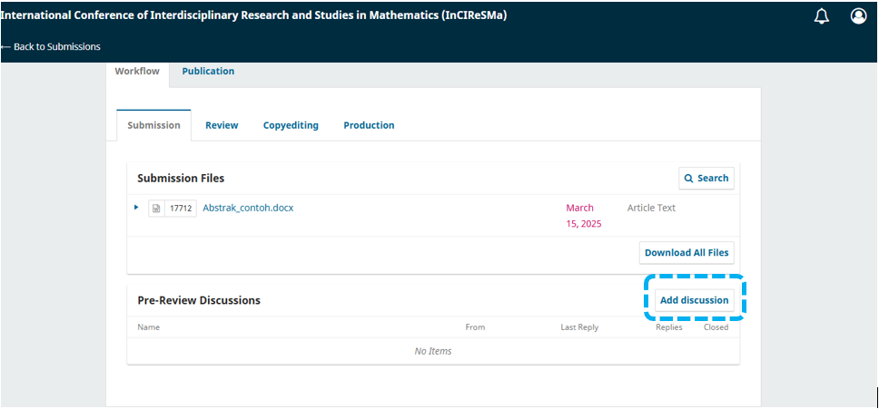

* + Please check “Author”, “INCIRESMA admin, journal editor” to ensure proper access and review of the submission.
  + Select “Full Paper” as the subject
  + Add a message (if necessary)
  + Click “Upload File” and attach your manuscript

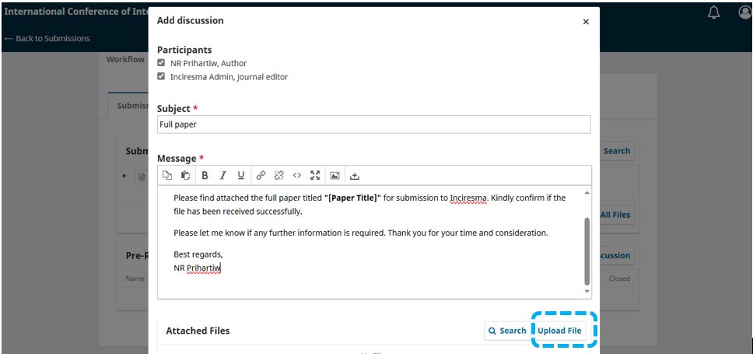

* + Click “Continue” and then “Complete”

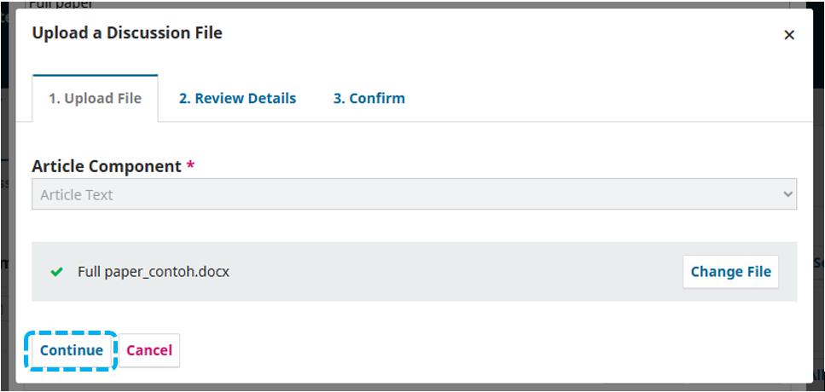



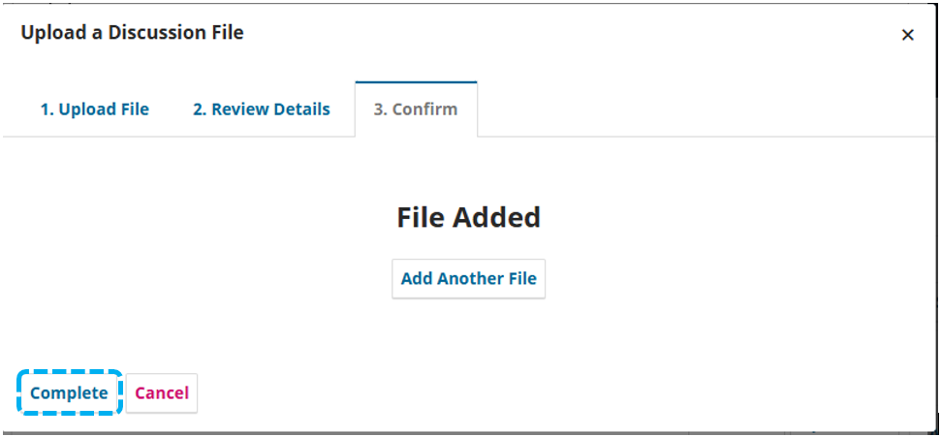

* + The full paper will appear in the attached files section; confirm by clicking "OK"  
    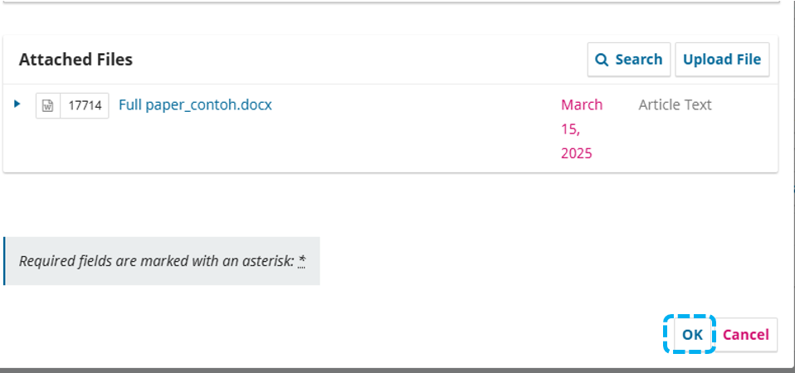
  + If the submission process is successfully completed, the submission menu will be displayed as follows.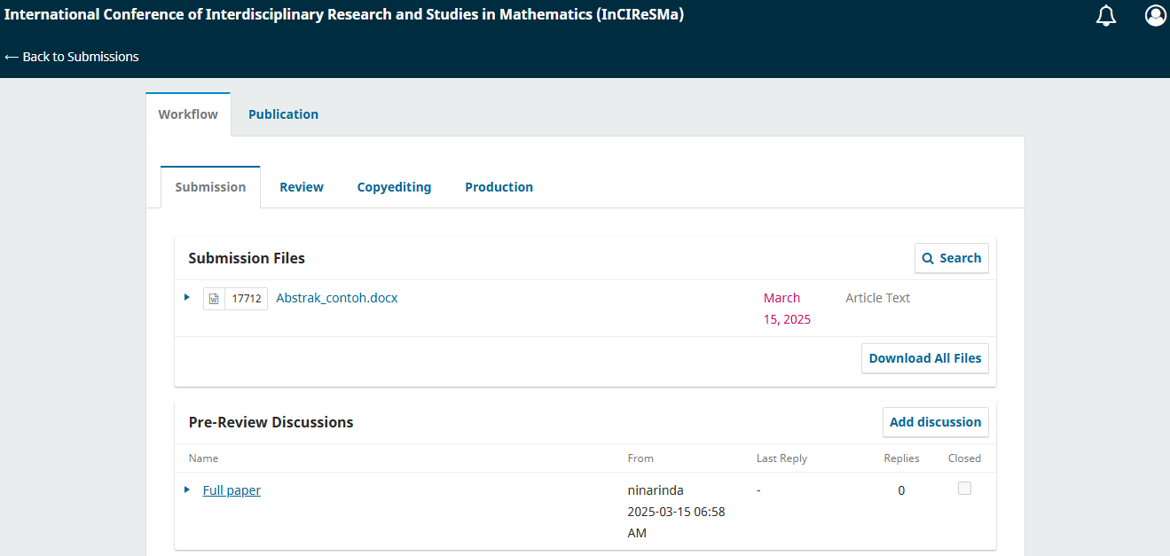

# Registration Payment

* Presenters are required to pay the registration fee as stated on the website to the designated bank account.
* Proof of payment must be uploaded via the INCIRESMA registration form.

# INCIRESMA 2025 Registration

* Participants, presenters, and general attendees must complete the online registration form to join INCIRESMA 2025.
* The registration button is available in the top corner of the official website.



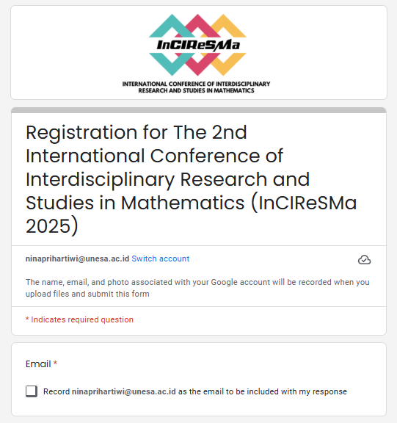

# Notification of Full Paper Acceptance

* + Authors of accepted manuscripts will be notified through the OJS 3 system and their registered email.
  + Authors of accepted manuscripts will receive an acceptance letter along with an invoice for the publication fee.

# Revision Paper

* Authors must revise their manuscripts based on the reviewers' comments and submit the revised version through the OJS 3 system.
* The quality of the revised manuscript is crucial; if the revisions do not meet the reviewers' suggestions, the article may be rejected by the editor.