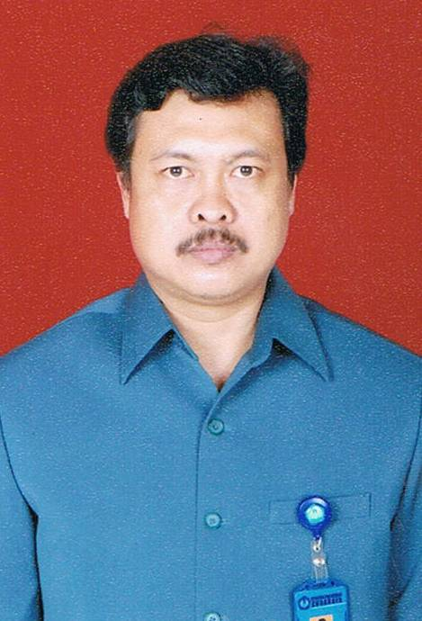
Drs. Supardiyono, M.Si

Position | Lecturer of Geophysics in Physics Study Program
Position | Assistant Professor of Geophysics in Physics Study Program
Position | Degree |  | University |  | Year
Academic career | Bachelor at Physics Education |  | Universitas Negeri Surabaya - Indonesia |  | 1991
Academic career | Master of Science |  | Universitas Gadjah Mada - Indonesia |  | 1998
Employment | Position |  | Employer |  | Period
Employment | Lecturer on Physics Study Program |  | Universitas Negeri Surabaya - Indonesia |  | 1992- now
Employment | Computational Laboratory Coordinator |  | Faculty of Mathematics and Natural Sciences, Universitas Negeri Surabaya - Indonesia |  | 2019-now
Employment | Lecturer on Open University |  | UPBJJ-UT  Surabaya - Indonesia |  | 2007-now
Research and development projects over the last 5 years (2014-2019) | Penentuan Struktur Kecepatan Gelombang P Dan S di Bawah Jawa Timur dan Tengah dengan Inversi Tomografi Lokal (Rp. 62.500.000,00) |  |  |  |  | 2014
 | Penentuan Struktur Kecepatan Gelombang P Dan S di Bawah Jawa Timur dan Tengah dengan Inversi Tomografi Lokal (Bath II)(Rp. 70.000.000,00) |  |  |  |  | 2015
 | Analisis Potensi Sungai Bawah Permukaan Daerah Kars Di Kecamatan Rengel Kabupaten Tuban (Rp.50.000.000,00) |  |  |  |  | 2016
 | Pemanfaatan Co₂ Cair Sebagai Refrigeran Dalam Sistem Penyimpanan Ikan Bagi Nelayan Di Kec. Brondong Kab. Lamongan (Rp. 41.000.000,-) |  |  |  |  | 2016
 | Pengembangan Bahan Ajar Digital Interaktif (BADI) untuk pembelajaran Online Fisika Terapan  Hibah Penelitian Kebijakan Unesa (Rp.7.500.000,-) |  |  |  |  | 2018
 | 2019: Peningkatan Kompetensi Kreativitas Mahasiswa Pgsd Dengan LKM Model Teaching Learning And Creativity (TLC) Pada Mata Kuliah KONSEP DASAR IPA DI SD (PDGK4103)  Hibah Penelitian Dasar Open University (Rp. 50.000.000,-) |  |  |  |  | 2019
 | Penerapan Pola Komunikasi Interpersonal Jarak Jauh Melalui Whatsapp (WA) Dan Onedrive Dalam Meningkatkan Hasil Mutu Pemantapan Kemampuan Profesional (PKP) Dan Karya Ilmiah Mahasiswa. Hibah Penelitian Dasar Open University (Rp. 50.000.000,-) |  |  |  |  | 2019
 | Peningkatan Kompetensi Kemampuan Pemecahan Masalah Matakuliah Tap Melalui Pemberian Guiding Question Model Problem Solving Mahasiswa PG-PAUD di Pokjar Bojonegoro.Hibah Penelitian Terapan Unggulan Perguruan Tinggi Open University (Rp. 50.000.000,-) |  |  |  |  | 2019
 | Seleksi Tutor Secara Integratif Dalam Upaya Meningkatkan Kualitas Tutorial Untuk Ciptakan Budaya Mutu Akademik Hibah Penelitian Terapan Unggulan Perguruan Tinggi, Open University (Rp. 50.000.000,-) |  |  |  |  | 2019
Important publications over the last 5 years | Three Component Seismogram Analysis: A Case Study of the M=7.7 South Java Indonesia Earthquake on July 17, 2006 and Changes in Coulomb LAZStress and Seismisity Rate. Journal of Computational and Theoretical Nanoscience. 23(12). 12037-12042 |  |  |  |  | 2017
Important publications over the last 5 years | Determination of source parameters of the 2017 Mount Agung Volcanic earthquake from moment-tensor inversion method using local broasband seismic waveforms. J. Phys. Conf. Ser. 997. 012001 |  |  |  |  | 2018
Professional Organization | Organization | Position |  | Period
Professional Organization | Physical Society of Indonesia (PSI) | Member |  | 2018 – Now
Professional Organization | Himpunan Ahli Geofisika Indonesia (HAGI) | Member |  | 2017 – Now

