Module Handbook
Module Name : | Geometri Transformasi  Transformational Geometry
Module level : | Bachelor degree/Undergraduate Program
Course Code : | 4420103045
Abbreviation, if applicable: | -
Courses included in the module, if applicable: | Not Applicable
Semester/Term | 6th/ third year
Module coordinator(s) | Dr. Agung Lukito, M.S
Lecturer(s): | Dr. Agung Lukito, M.S  Rudianto Artiono, M.Si  Muhammad Jakfar, M.Si.
Language: | Bahasa Indonesia (Indonesian Language)
Classification within the curriculum: | Compulsory/ Elective
Teaching format/class hours per week during the semester: | 3 contact hours of lectures (sks or credit unit*)
Workload : | 3 x 50 minutes lectures, 3 x 60 minutes structured activity, and  3 x 60 minutes individual activity per week,  14 weeks per semester  119 total hours per semester ~ 4.77 ECTS**
Credit Unit: | 3 credit unit (4.77 ECTS)
Requirements: | Geometry, Analytical Geometry
Learning goals/competencies: | Knowledge (KNO-1) Demonstrating mathematical knowledge and mathematical insight.  CLO-1: Demonstrate mathematical knowledge and mathematical insight into the definition of geometric transformation and projective geometry  Competence (COM-1) Proving mathematical statements by various methods.  CLO-2: Prove mathematical statements in the geometric transformation and projective geometry
Content | This course discusses Generalities in Geometric Transformation, Affine Transformations, Orthogonal Transformations, Projective Incidence Properties, Homogeneous Coordinates, Cross Ratios and Projective Frames, Conics, Quadrics, Projective Transformations. Lecture activities are carried out in a student center with discussions, observations, project assignments, and presentations.

Attribute Soft skill: | Active communication; Discipline; Collaboration; Responsibility; and Argumentation in class.
Study/exam achievements: | The final grade (NA) is calculated based on the following ratio:  Assessment Components Percentage of contribution  Participation 20%  Assignment 30%  Mid-semester test 20%  Final semester test 30%  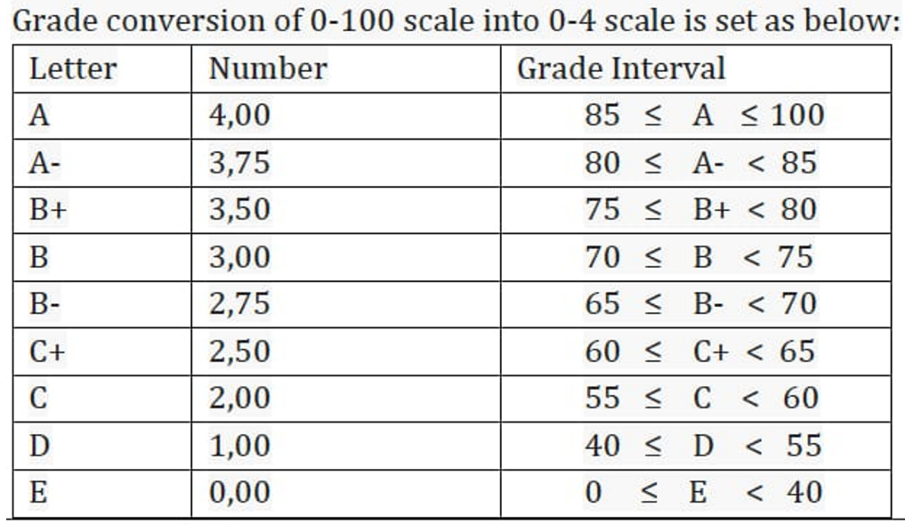
Learning Methods : | Student-centered approach; project-based learning; lecturer and discussion; and presentations (structured activities)
Form of Media: | Power point slides; video; worksheets, and textbooks
Literature (primary references): | - Ian Visman, 1997, Analytical Geometry (Series on University Mathematics). World Scientific Publishing Company  - Eccles, Frank R, 1971, An Introduction to Transformational Geometry, California, Addison Wesley Publishing Company  - Martin,George F, 1980, Transformational Geometry an Introduction to Symmetry, New York: Springer-Verlag
Notes: | *1 credit unit or sks in learning process = three periods consist of: (a) scheduled instruction in a classroom or laboratory (50 minutes); (b) structured activity (60 minutes); and (c) individual activity (60 minutes) according to the Regulation of Indonesia Ministry of Research, Technology, and Higher Education No. 44 Year 2015 jo. the Regulation of Indonesia Ministry of Research,  Technology, and Higher Education No. 50 Year 2018.
 | **1 credit unit or sks = 1.59 ECTS according to Rector Decree Of Universitas Negeri Surabaya No. 598/UN38/HK/AK/2019

